

TOP TIME OPEN HOUSE
at Beccles Library
Thursday 17th August
2.00 – 3.00pm
Suffolk Historic Churches Trust
Celia Stephens from Suffolk Historic Churches Trust is our guest speaker, and will be talking about the History of the Trust; grants for repairs and maintenance; the annual sponsored ‘Bike Ride’ and other events.

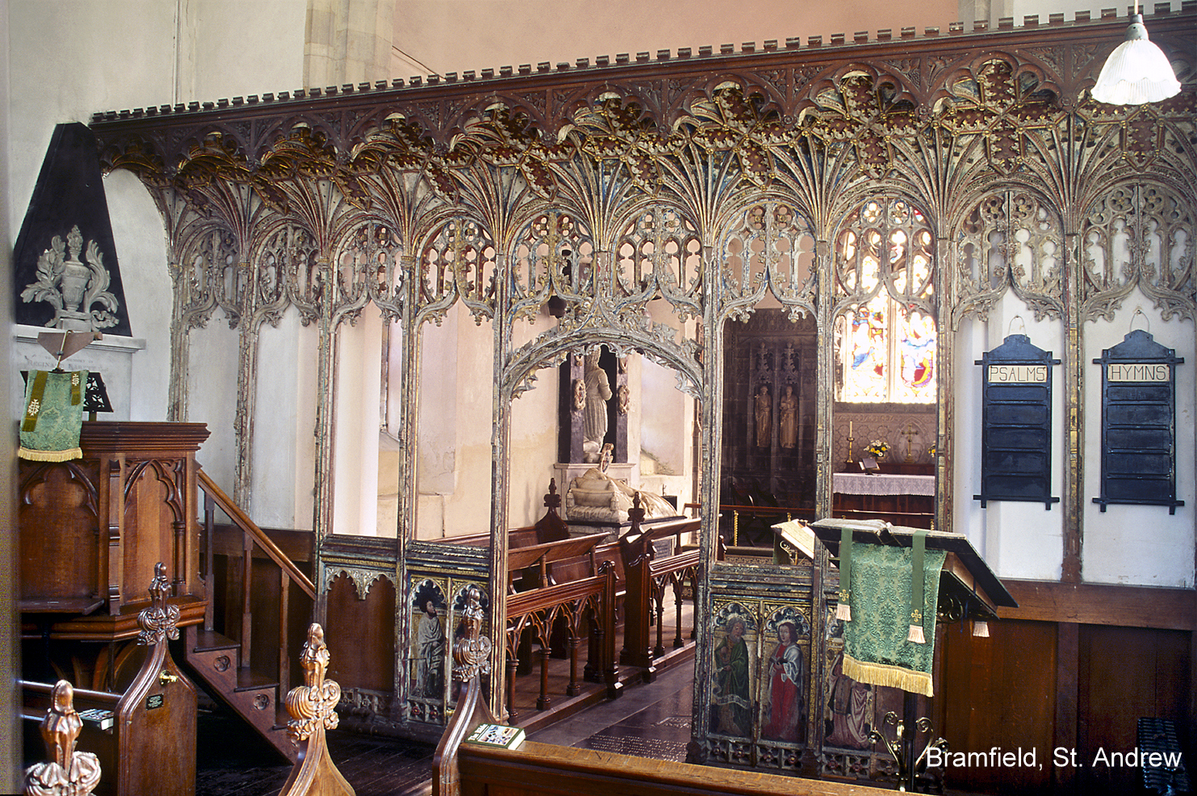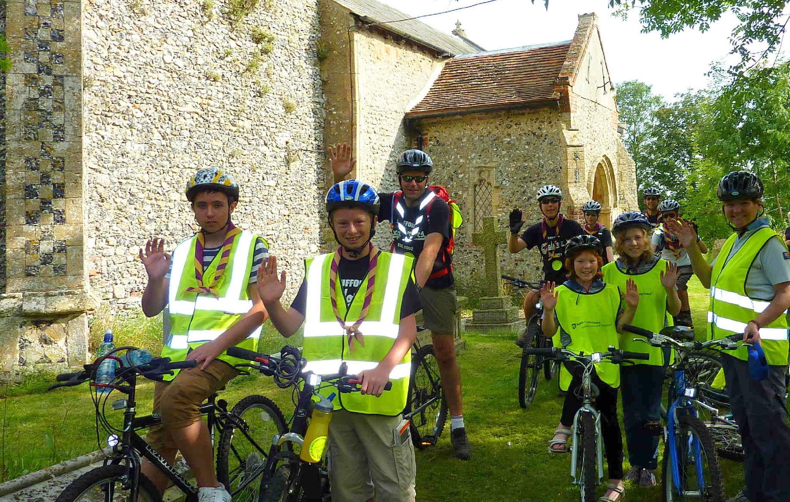

THE SPONSORED BIKE RIDE – 9th September 2017

The sponsored bike ride event is the Trust’s biggest fundraiser and is held annually on the second Saturday in September. It started here in Suffolk in 1982 and has now spread, as ‘Ride & Stride’, across the country. The money raised is shared between the participant’s chosen church and Suffolk Historic Churches Trust. Sponsors are now able to donate via .
For more information about donating or taking part in the Suffolk Historic Churches Bike Ride visit our website: www.shct.org.uk
No need to book. Refreshments available.

